Programming Languages
Spring 2019 Introduction to Prolog
Dr. Gurka

Activities
- Introduction to Prolog – see Sebesta, chapter 16, or another basic Prolog reference.
  - facts
father(bob, joe).
  - rules
parent(X,Y) :- father(X,Y).
  - queries / goals
?-father(bob,X). returns X = joe (& could be multiple answers)
  - reference / resource
SWI Prolog
- Variables start with an uppercase letter (syntax, not style).
- Examples
  - man(carl).
  - parent(jo, lee).
  - mother(M,C):-woman(M),parent(M,C).
  - uncle(U,N):-man(U),siblings(U,P),parent(P,N).
  - descendent(D,A):-parent(A,D).
descendent(D,A):-parent(P,D),descendent(P,A).
- Prolog – genealogy database – about 30 minutes, alone or pairs
  - create a basic family tree diagram (your own or made up)
  - develop a set of facts and inference rules (English) about family relationships in the tree: mother, father, sister, brother, sibling, aunt, uncle, cousin, etc.
  - read the two genealogy program handouts
- Who owns the fish? – part 1, about 20 minutes
  - read the problem statement
  - solve by hand and observe your strategies and algorithms
- Who owns the fish? – part 2, about 20 minutes
  - sketch out a design for a program in the C family to solve this particular problem; concentrate on program structure and algorithms, not code
  - groups of two: compare ideas for the program
- Who owns the fish? – part 3
  - brainstorm how to write a Prolog program to solve the fish problem

In-class work
Show me your genealogy database and explain your ideas for the Prolog version of the fish program.

Prolog set-up assignment
- Get a Prolog environment set up and experiment with your genealogy database. Become comfortable with facts, rules, and queries (minimum of one hour writing and learning Prolog).
- Experiment with the fish problem (perhaps a simpler version) to develop a solution.
- Look at several online Prolog solutions to the fish problem.

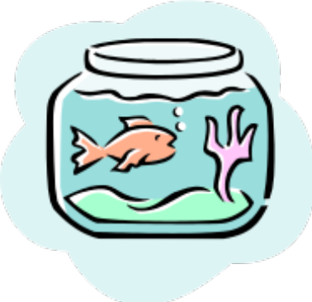
Who owns the fish?

Rules
- There are 5 houses, each a different color.
- In each house lives a person of a different nationality.
- Each person drinks a different drink, smokes a different brand of cigarette, and owns a different animal.

Facts / Constraints
- The Englishman lives in the red house.
- The Swede owns a dog.
- The Dane loves to drink tea.
- The green house is on the left of the white house.
- The green house’s owner drinks coffee.
- The person who smokes Pall Mall owns a bird.
- The person who lives in the middle house drinks milk.
- The Norwegian lives in the first house.
- The person who lives in the yellow house smokes Dunhill.
- The Marlboro smoker lives beside the person who owns a cat.
- The man who owns a horse lives beside the person who smokes Dunhill.
- The Winfield smoker drinks beer.
- The Norwegian lives beside the blue house.
- The German smokes Rothmanns.
- The Marlboro smoker has a neighbor who drinks water.

Goal
Figure out who owns the fish.

